Image | 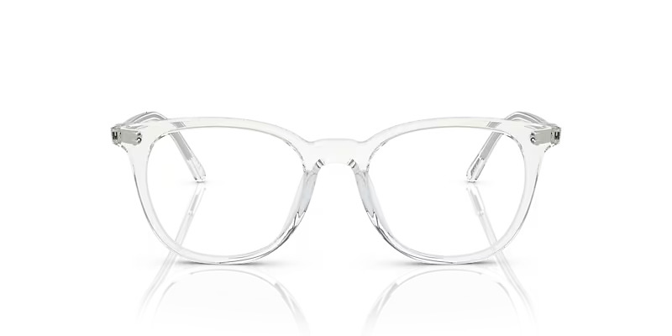
Brand | DIOR
Model Name | JOSIANNE
Price | RS 2499
PRODUCT DETAILS

